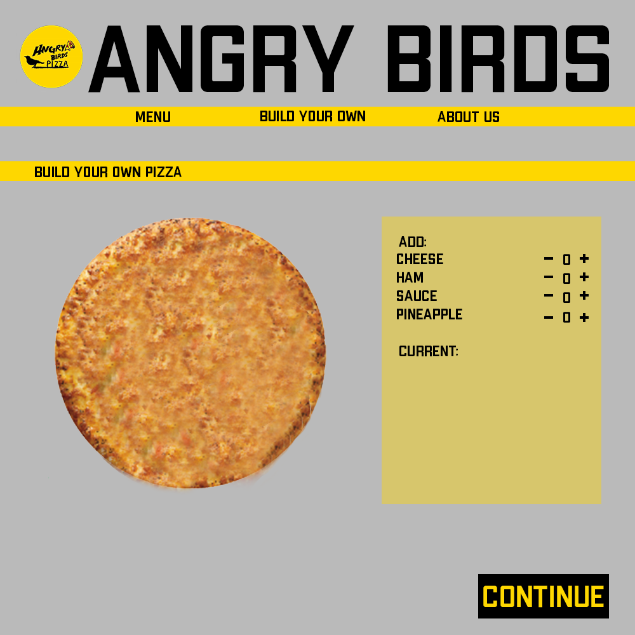**Build your own Pizza**

Figure 1: Hungry Birds Build your own pizza layout

Validation Testing;

In this page, the user will be shown a picture of the pizza crust with nothing else, with a list of pizza toppings on the side. The items Shown are the items essential for a normal pizza and once a user adds an item to the pizza, a real time picture of the ending product will be displayed on the left while the item will be added onto the current list just below the add list.

To test this feature, we would ensure that whenever the user adds an item by pressing the addition sign the topping would be displayed as it should on a normal pizza with the end product displayed to the left, while the item will be added onto the current list, which will remain blank and if the user is not interested in a certain topic or changes his/her mind, they can remove it by tapping the subtraction sign on the add list which will remove it from the current list section until an item is added onto the pizza and once the user is done, he/she can tap the continue button.

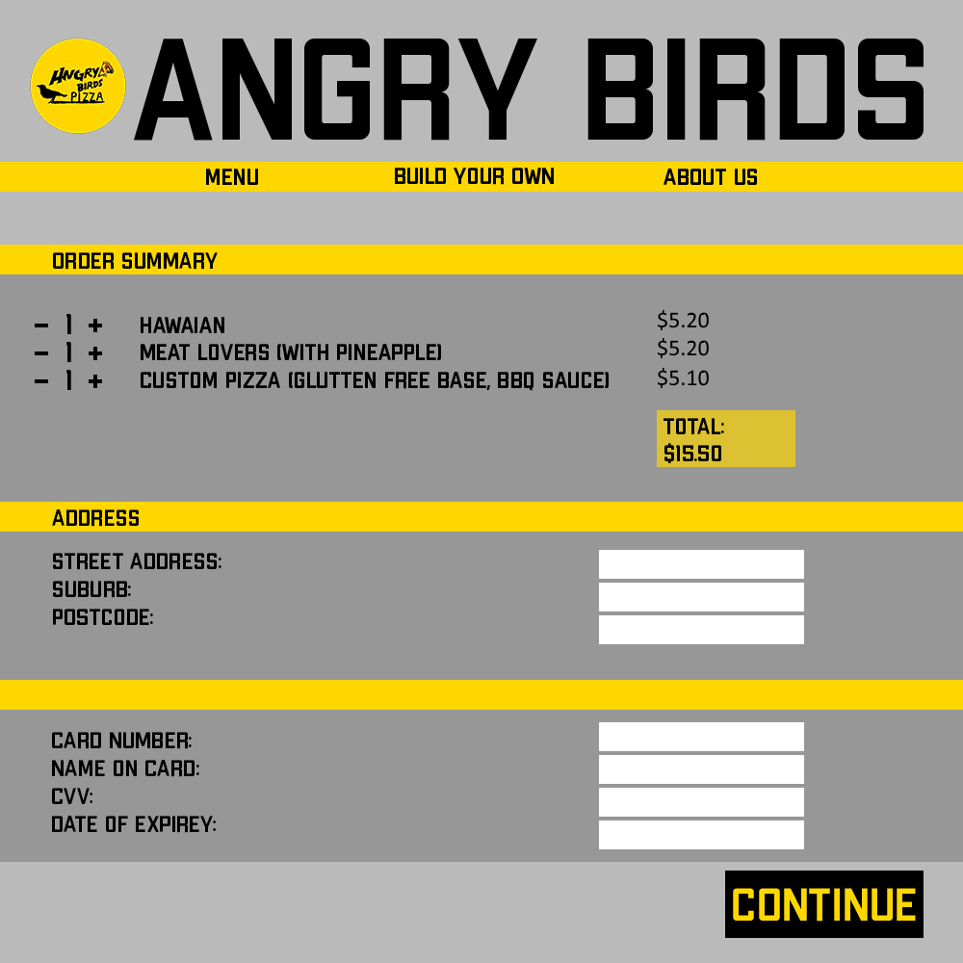

**Place your order**

Figure 2; Hungry Birds Place order feature

Validation Testing;

Once after, either building their own Pizza, Choosing a Pizza or customising an existing one, the user will be redirected to this page where they will check out their order, in this page the user will see all their pizza choices with their prices and the total will be displayed below the list on the order summary section, they will also have to add their Address which includes the street, suburb and postcode then lastly the user will enter their card number, the name card , CVV and date of expiry in order to pay and successfully check out.

For testing, we would give the user an option to add more of the same Pizza or remove it while pressing the add or subtract button respectfully while displaying the price and totals

Also we would like to link the address section to google maps to avoid wrong and/or inn accurate addresses. And for the card section we would link it to several bank sites to avoid being conned with counterfeit card numbers.